**Witches literature and materials:**

1. <http://www.faculty.umb.edu/gary_zabel/Courses/Phil%20281b/Philosophy%20of%20Magic/Arcana/Witchcraft%20and%20Grimoires/case_witchhunts.html>

Case Study:   
The European Witch-Hunts, c. 1450-1750

* Male "witches" section

* Witch-hunts today section

1. <http://www.shca.ed.ac.uk/Research/witches/introduction.html>

introduction to scottish witchcraft

Many Q and A we could use

Q. Were they widowed?  
A. It's hard to say. Of those women whose marital status was recorded the majority were married—78%. Those who were recorded as widowed accounted for 19%. But marital status is unknown for the great majority of those accused. The problem is that a married woman would be more likely to have her status recorded, because she had a husband with an interest in his wife's trial. An unmarried woman or widow did not need to have her marital status mentioned. So these figures are probably untypical, and at present we don't know how untypical.

Q. Were they poor?  
A. No, at least not by contemporary standards. It is difficult to classify early modern people into socio-economic categories, but of those individuals whose status was indicated the majority fell into the middle range—64%. The total of those who came from lower socio-economic categories—lower, very poor and landless—accounted for 29%, with upper, lairds and nobility accounting for 6%. We do not know this information for the majority of those accused, but these figures may be typical.

1. <http://witches.shca.ed.ac.uk/index.cfm?fuseaction=home.graph2>

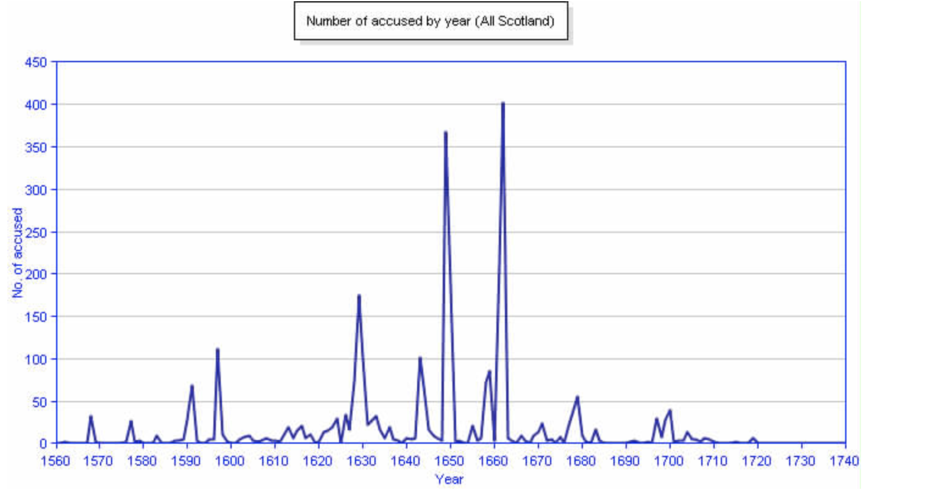

1. <https://www.gla.ac.uk/myglasgow/specialcollections/virtualexhibitions/damnedart/scotland/#d.en.189372>

Witchcraft and Demonology in: Scotland

1. <https://exemplore.com/wicca-witchcraft/Scottish-Witch-Remedies>

Scottish Witchcraft: Background and Practices

1. <https://search.ancestry.co.uk/search/db.aspx?dbid=61099>

Witches names